

**By Zealand Institute of Business And Technology**

* Mikkel Frederiksen **The AP degree in Computer Science**
* Rasmus Lunddahl Overbye **Semester 1 – Project -**
* Donatas Adamonis
* Simonas Valaitis
* Marcin Zelent December 2016

**Table of Contents**

1. Project Problem and Vision Definitions 2

2. Business Model Canvas 2

3. SWOT analysis 3

4. Value Chain 5

5. Porter’s five forces 5

6. Use case 5

7. Domain Model 6

8. Model Classes Diagram 6

9. ViewModel Classes Diagram 8

# Project Problem and Vision Definitions

France Vacances offers a wide variety of rental accommodation mainly for short period vacation all around the Europe. However, biggest problem that the company is currently facing is getting in contact with new or existing customers because of the only possible communication channel - phone calls. Due to the big demand from the public to acquire a new way to browse and book an accommodation: faster, easier and online, than a phone call.

Company’s vision is to implement software that would allow customers to plan their vacation and book an accommodation without having to call the company itself.

Facing the problem straight on, group created an short analysis of the company including Business Model Canvas and SWOT analysis, also, the solution to France Vacances’ problem. Software, that greets the customer with current discounts of services, ability to create a user and log in. Furthermore, customer can browse catalogue without any struggles, it is easy to use and visually appealing. After searching and choosing the accommodation, customer can easily book it for required time, room time, bed count, etc.

# Business Model Canvas

A short presentation of Business Model Canvas for company France Vacances will provide a better inside view of the company:

**Key Partners:** Owners of the property that France Vacances are renting out for their customers; Cleaning, law, networking companies that provide utility and legal support.

**Key Activities:** Renting accommodation, with a target segment of holiday seekers; Channel brochures, dedicated support and PR activities.

**Channels:** Currently only channels are high street salesman, brochures, and phone salesman. An idea is to implement an online booking system, which would be most cost efficient goal.

**Customer Segments:** people who are planning their holiday, adults, recently married couples, tourists.

**Revenue Streams:** Customers are paying France Vacances for providing them accommodation for a limited period of time; Currently, the only way customers are able to pay for the service they are buying is with the credit card over the phone with phone salesman; High demand for online payment option.

*Figure 1: Business Model Canvas*

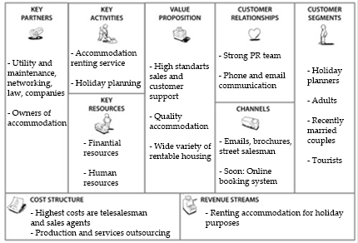

Source: own production

# SWOT analysis

**Strengths:** Strong and smart marketing and customer support; strong customer relationships because of the good reputation; Big sales team allows the company to reach big numbers of potential customers generating majority of the revenue.

**Weaknesses:** France Vacances does not offer online booking, which is what customers want; Sales team salaries are very big part of company’s liabilities, implementing an online booking system, France Vacances would cut a big part of costs.

**Opportunities:** Investing into IT team and online support and shrinking a telesales man team is the most profitable option for France Vacances at the moment.

**Threats:** Biggest threat of such business shift is many new competitors; Possible expenses for marketing projects, new employee hiring and trainings.

*Figure 4****: SWOT Analysis***

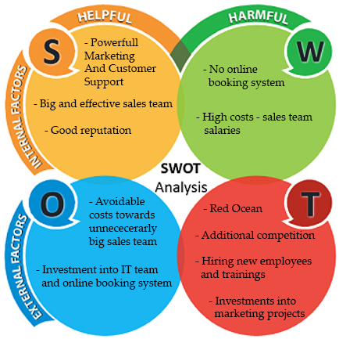

Source: own production

# Value Chain

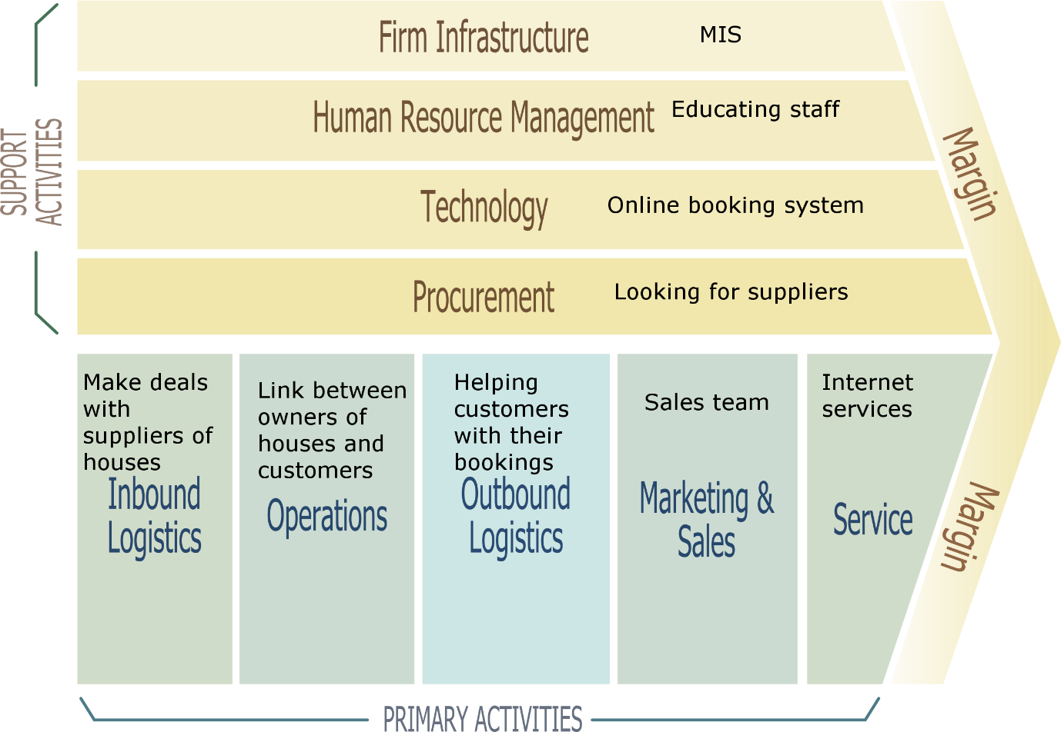

# Porter’s five forces

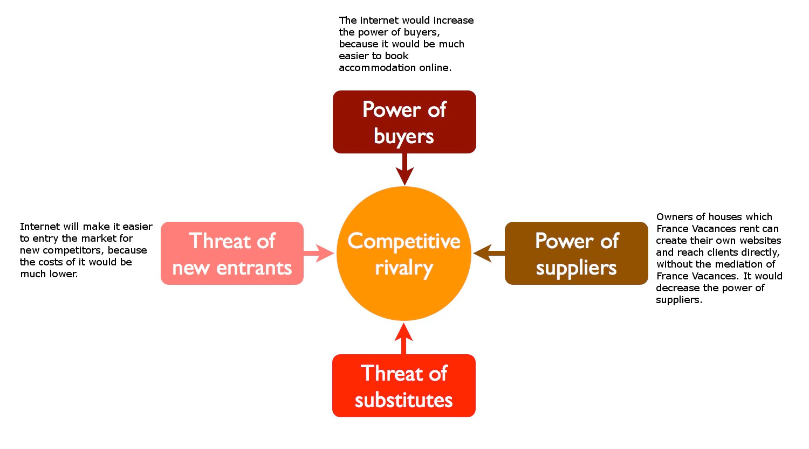

# Use case

**User wants to book a cottage.**

**User** will be able to search from the **front page** on where he wants to go.

When he have found the **cottage** he wants, he clicks on the **offer**, gets more details about the offer. User chooses the dates and then he press the Book button.

He will then be sent to the**booking page**, where he will put information about him and confirm **booking**. When booking is confirmed, he will be shown a dialog informing about success.

# Domain Model

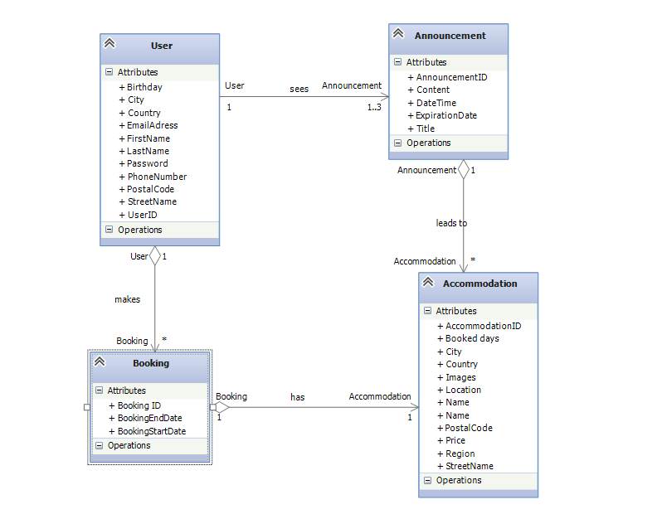

*Figure 2: Domain Model*

Source: own production

# Model Classes Diagram

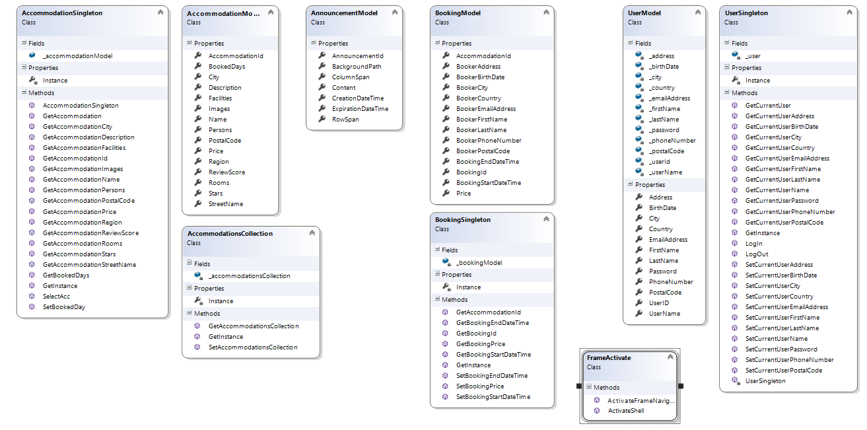

# ViewModel Classes Diagram

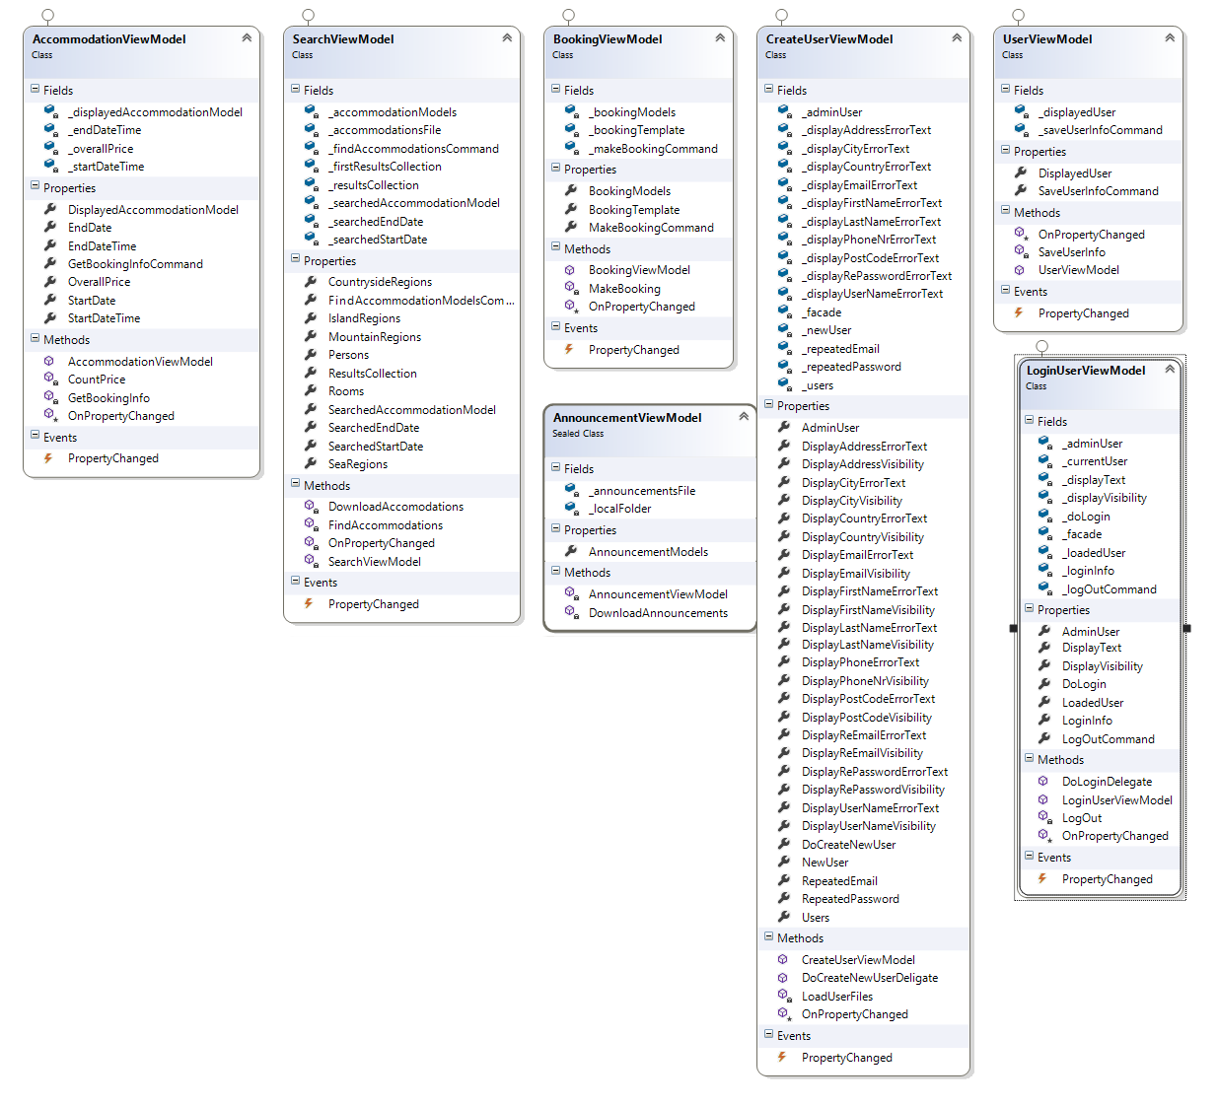

# Sequence Diagrams

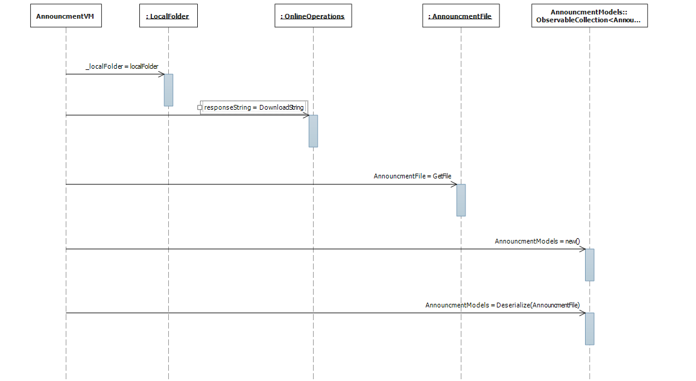

AnnouncementViewModel sequence diagram

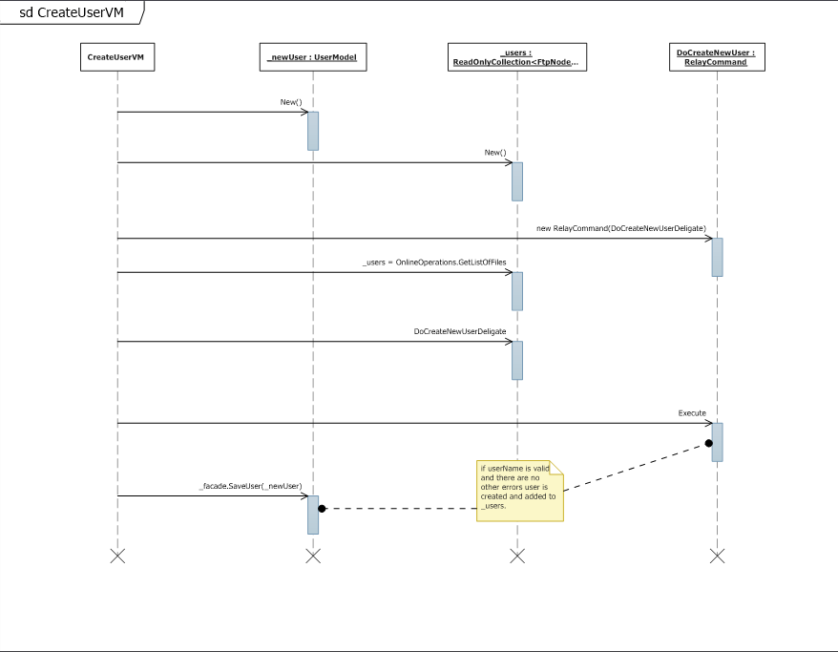

CreateUseVM sequence diagram

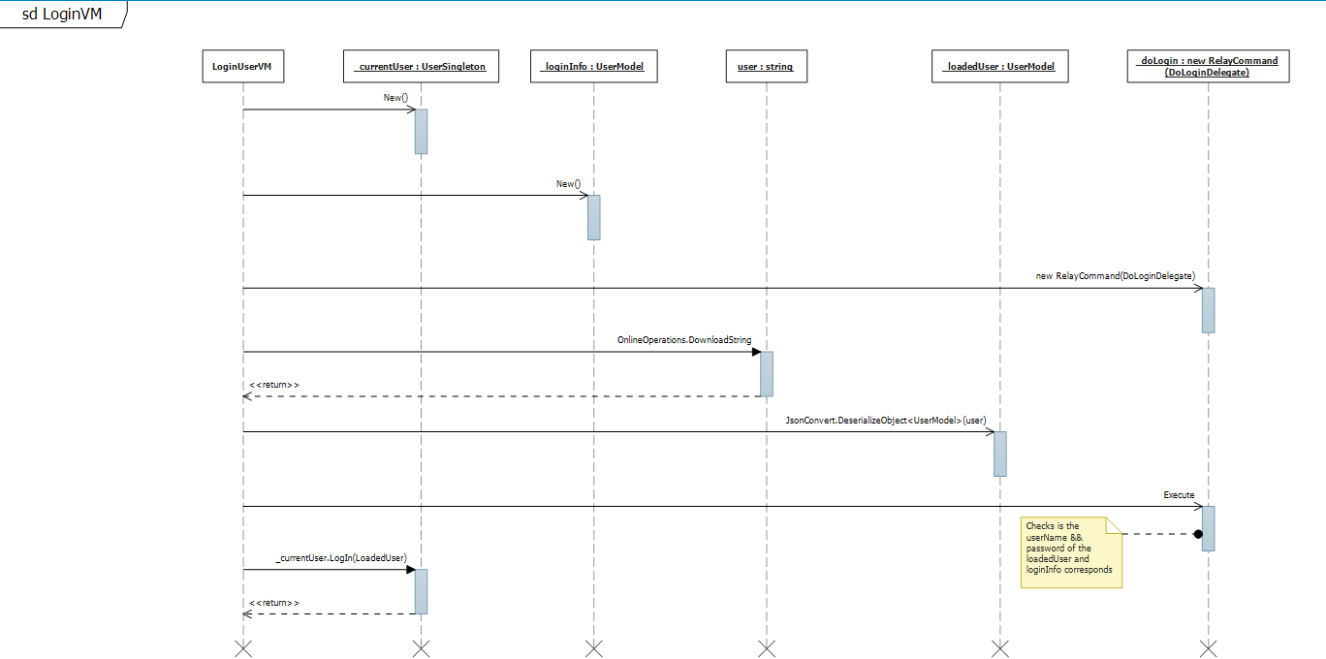

LoginUserVM sequence diagram

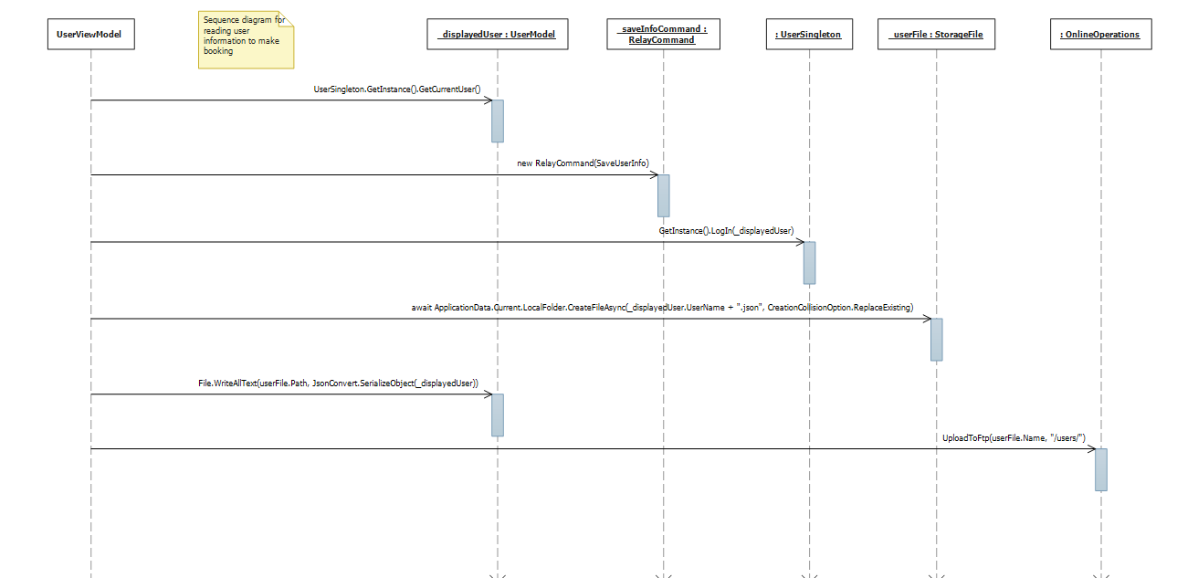

UserViewModel sequence diagram

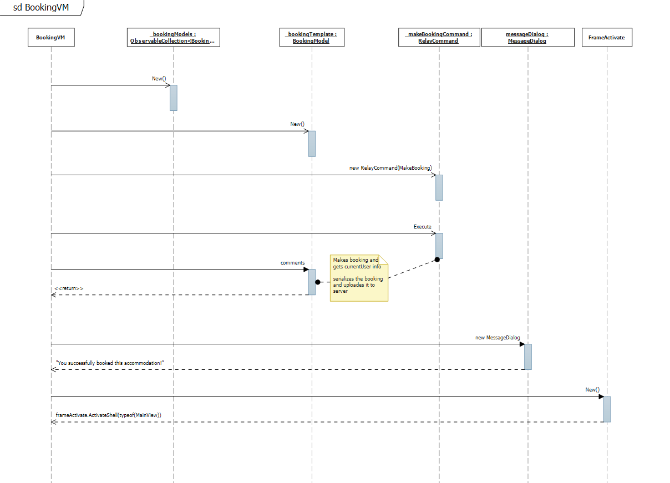

BookingVM sequence diagram

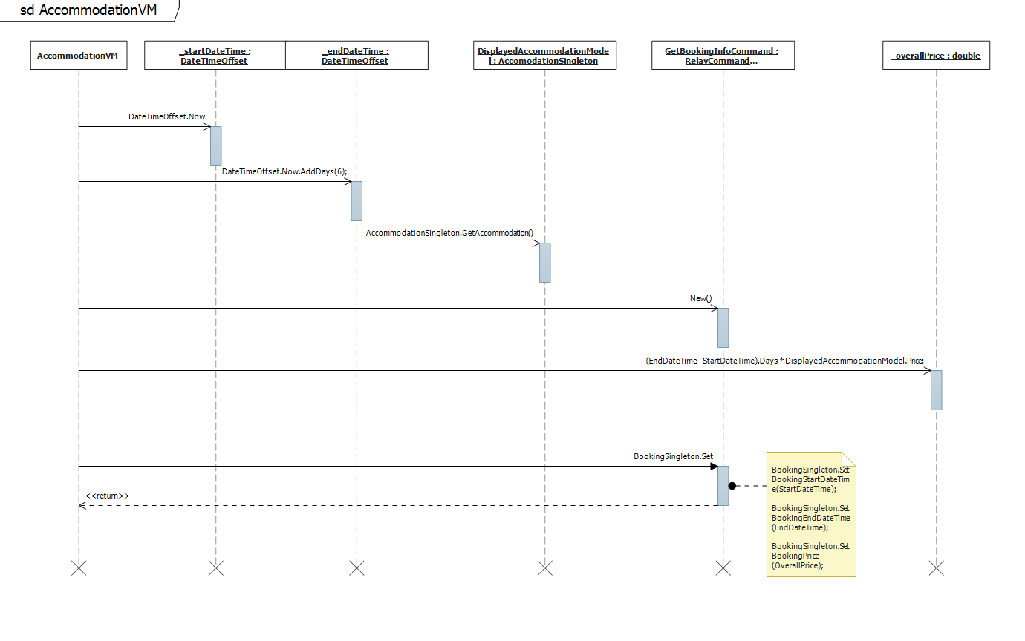

AccomodationVM sequence diagram